BUSINESS REQUIREMENT DOCUMENT

<<AdHoc BRD: New Enhancement Features>>

<<Dhawal Sah>>

<<Aravind Ravi Sankar>>

**VERSION: 1.0**

DATE <<2022-05-24 >>

**TABLE OF CONTENTS**

**1.1 Problem Statement/ Requirement Background** **3**

**1.2 Current Solution/Process (if any)** **3**

**1.3 Related Documents** **3**

**1.4 Solution Scope** **3**

**1.5 Constraints** **3**

**1.6 Business Goals and Objectives** **3**

**1.7 Priority** **3**

**1.8 Target User/ User Community** **3**

**1.9 Impact Analysis** **4**

**1.10 Additional Information** **4**

**1.11 Stakeholder consultation** **4**

**1.12 Approvers** **4**

### 

### 1.1 Problem Statement/ Requirement Background

What are the current problem statements faced by the Business owner?

Currently there are three major problems faced:-

1. There is no method for filtering the activity of an aspirant
2. Aspirants are not able to send attachments in their query request to Career Coaches
3. Aspirants are not able to send their queries to Placement POCs and request a callback from them

Provide a brief introduction to the project. This includes describing the business context of the project and the users.

1. Track activities is a feature used to track all the activities/ interactions that occur with an aspirant. We need a filter for the track activities so that we can easily search for any activity that has occurred with the aspirant.
2. There is a requirement for attachment feature in the Query box for Career Coach Call request from an aspirant. This is because aspirants have a lot of queries that cannot be explained through words and need to attach an image/video or recording.
3. There is a requirement of *Request Call with Placement Coordinators* feature. Aspirants can now send their queries to Placement Coordinators and request a call back from them. Currently this feature is available for requesting callback from Career coaches but it should be extended for Placement coordinators too.

### 1.2 Current Solution/Process (if any)

Describe the current environment as it relates to the solution scope for this document. Does the client have an existing solution? What is it? What are some of its key challenges? What is being done manually?

Currently Track Activities is a feature used to add Interaction activities for an aspirant. Some of its features are:

* Ability to add disposition for the activity done
* Ability to add a comment for the Disposition
* Ability to add Trainer comments
* Ability to add Daily Career Coach Tasker

Currently Request a call to Career Coach is a feature used to request calls to Career Coach by an aspirant. Some of its features are:

* Comment Box to enter query to Career coach
* This query is received by Career Coach
* The content in the Query box sent by aspirant can be viewed by Career Coach in the description column in Call Requests on CRM
* The Career Coach has to resolve the query on call and submit the Resolve button with a message.

If the current solution has financial impacts, provide a high-level description.

### 1.3 Related Documents

Reference any business deliverables/documents associated with this requirements document.

### 1.4 Solution Scope

Define the scope of the solution that this document describes. Indicate any components no longer in scope (e.g., scope changes from that described in the Preliminary Scope document).

Business needs are of the following two enhancements for features. These are:-

1. Filter for Track Activities: The filter should have multiple choice options. Also the filter should be based on Dispositions and not on comment box content.
2. Attachment in Request Callback comment box: Aspirant should be able to attach any file or folder. This file might be a video, voice recording, PDF, etc.
3. Request call from Placement Coordinators: Aspirants should be able to request calls from their Placement Coordinators. Also the queries should be visible in Placement Calls Tab. This feature should be exactly similar to the Career Coach Call Request. Further the Placement coordinators should call the aspirants in order to resolve their queries in a given TAT time.

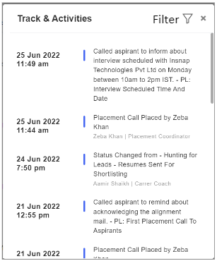

**Filter for Track Activities**

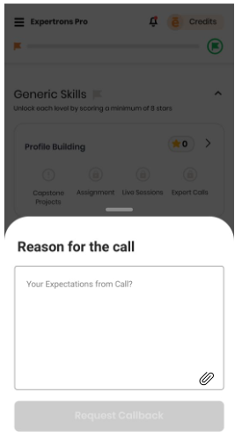

**Attachment in Request Callback comment box**

### 1.5 Constraints

What are the business goals and objectives we are trying to achieve with this project

### 1.6 Business Goals and Objectives

What are the business goals and objectives we are trying to achieve with this project

Implementing these features would lead to a smoother functioning of the business. Aspirants would be able to easily attach attachments and send their query to Career coaches. Further filtering the track activities would also save time in analyzing the interaction record of aspirants. Also trainers would be able to see the progress of the aspirants by using filters on Trainer comments. Track activities can also be easily filtered for support teams in case of extreme situations. Addition of Placement Callback request feature would lead to aspirants’ placement queries getting solved on time and increased interaction between placement coordinators and aspirants

### 1.7 Priority

Use the following three categories to prioritize requirements (do not introduce and mix other prioritization methods such as the MoSCoW method):

* **High** to indicate a solution element that is critical to the client’s business function and operation;
* **Medium** to indicate a non-critical solution element that provides significant benefit to the client; and
* **Low** to indicate a non-critical solution element that provides a helpful or convenient feature that is beneficial to the client.

| **Feature** | **Priority** |
| --- | --- |
| Track Activity Filter | High |
| Attachment in Request Callback comment box | High |
| Request callback from Placement Coordinator | High |

### 1.8 Target User/ User Community

If applicable, identify all possible user groups for the solution.

For each user group, estimate the number of users and reference the functional areas each will need access to.

For Track Activity Filter:

* All The Trainers,
* Career Coaches,
* Placement Coordinators,
* Placement Group Leaders

For attachment in Career Coach request call query box:

* All the Aspirants,
* All the Career coaches

For Request callback from Placement Coordinator:

* All the aspirants in placement phase
* All the Placement POCs

### 1.9 Impact Analysis

How is this product/feature

Adding a Filter to track activities would reduce the manual task for searching any activity in the List and also using multiple filters we can search for multiple activities together,

Having an attachment feature to the Query Box would help aspirants to send their queries easily. Also aspirants would no longer be sending screenshots to personal WhatsApp numbers of Career Coaches. All the query attachments would be saved in CRM itself and can be seen by all the Career Coaches and other associated stakeholders.

Adding a *Request callback from Placement Coordinator* feature would lead to early resolving of aspirant queries related to their placement process. The interaction between the aspirants and POCs would increase and the placement process would be smoother.

### 1.10 Additional Information

Include any information related to the requirement (e.g., hyperlinks to related online content). Where appropriate:

* Reference the associated business process model within the *Business Process Definition* document; and
* Identify the owner (e.g., source) of the requirement.

**1.11 Stakeholder consultation**

Identify the stakeholders for the solution and for the project, what their role(s) are, and whether they were consulted.

| **Stakeholder Name** | **Role** | **Consulted** |
| --- | --- | --- |
| Aravind Ravi Shankar | Reviewed the BRD and suggested changes | Yes |
| Dhawal Sah | AVP - T&P Team | Yes |
| Kamran Ansari | Consulted regarding Attachment in Comment Box | Yes |

### 

### 

### 

### 1.12 Approvers

The following individuals have approved the financial requirements on the date indicated.

| **Approver Name** | **Role** | **Approved** |
| --- | --- | --- |
|  |  | << Yes / No >> |
|  |  | << Yes / No >> |
|  |  | << Yes / No >> |